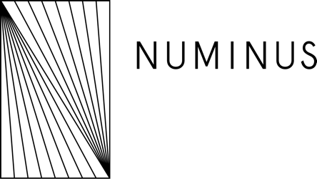

# Equivalency Exam: Part 3

40 points

The Numinus care model is comprised of seven guiding principles which we at Numinus believe health professionals working with psychedelic-assisted therapy should work to embody in order to create a safe and supportive space for clients. The Numinus care model is comprised of seven guiding principles:

* Connection (relationship-centered care)
* Embodiment
* Mindfulness
* Trauma- and violence-informed care (TVIC)
* Cultural safety and *humility*
* Justice, equity, dignity, and inclusion (JEDI)
* Harm reduction

In 1000-2000 words or in a 10-minute recorded video, please explain for each of the seven guiding principles:

* How you see each principle as being relevant and applicable to the provision of psychedelic-assisted therapy
* How you embody and actively cultivate each principle

In your response, please provide concrete examples of how you embody each principle. There may be some guiding principles that may not be strengths of yours yet, so please explain how you are actively working on developing and embodying these principles within your practice. Ongoing learning and reflection are common themes throughout all principles of the Numinus care model. Therefore, you are also encouraged to reflect on ways you are continually learning and developing your skills, even if you are skilled and competent in a particular area. Please avoid disclosing confidential or sensitive information that is not your own experience. You are encouraged to use pseudonyms or slightly distort any examples that involve others/clients to protect their confidentiality.

### Your Response

1000-2000 words / 10 minute video